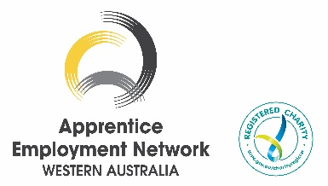
WINNERS ANNOUNCED
2025 AWARDS FOR EXCELLENCE

Media Statement: 6 November 2025
_________________________________________________________________________________

On Friday, the 31st of October, we had the pleasure of hosting the 2025 Awards for Excellence presentation ceremony at Burswood on Swan.
This event was a wonderful opportunity to celebrate and acknowledge the remarkable achievements of our members’ top-performing apprentices and trainees, and to recognise the importance and value of the host employers who support their skill journey and make their success possible.
Congratulations to all our Award category winners and their Group Training Organisation Employers:
WINNER | CATEGORY & SPONSOR | EMPLOYER & MEDIA CONTACT
Dan Bulman | Apprentice of the Year – Sponsor, AustralianSuper | MEGT- Ja Turnbull, jat@megt.com.au
Joshua Pepper | Aboriginal and Torres Strait Islander Apprentice / Trainee of the Year – Sponsor, HydraTune | WPC Group – Kerrie White, Apprentice & Trainee Manager kwhite@wpcgroup.org.au
Kayla Upton | Woman in Building and Construction Apprentice /Trainee of the Year – Sponsor, Construction Training Fund. | Directions Workforce Solutions – Vicky Dhu, Group Training Manager vicky@directionswa.com.au
Joel Yates | Trainee of the Year – Sponsor, Apprenticeship Support Australia (powered by CCIWA) | MEGT- media contact, Ja Turnbull, jat@megt.com.au
Natasha Heath | School-Based Apprentice / Trainee of the Year – Sponsor, MEGT | Maxima Training Group - Nadene Carr, State Manager WA Nadene.carr@maxima.com.au]
SANDVIK | Host Employer of the Year –  Sponsor, Busy At Work | The Apprenticeship Community | GTO Partner -Directions Workforce Solutions. - Vicky Dhu, Group Training Manager vicky@directionswa.com.au

With 164 people in attendance, including apprentice and trainee finalists, their families, employers, AEN WA members, sponsors, charity and business partners, it was an outstanding evening of celebration and recognition for their achievements.
We were honoured to have as our keynote speaker, the Honourable Amber-Jade Sanderson, Minister for Energy and Decarbonisation; Manufacturing; Skills and TAFE; and the Pilbara. Most importantly, it was wonderful to have the Minister’s support in congratulating our finalists and winners on stage, which added great significance to their achievements.
The stories shared by our finalists throughout the night highlighted the remarkable journeys of the apprentices and trainees, making the event a memorable celebration of vocational excellence.
A sincere thank you to everyone who joined us and made the evening an unforgettable occasion.
The success of the event was made possible by the generous support of our sponsors.
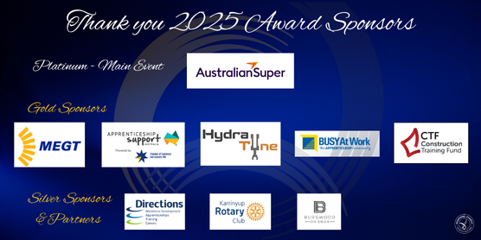

_________________________________________________________________________________________
Media Contact: Irene Walker, Executive Officer, 0412 183 776 eo@aenwa.com.au
The Apprentice Employment Network WA is the state's peak body, representing a network of 22 member Group Training Organisations that employ apprentices and trainees throughout Western Australia. Aenwa.com.au

